

User Guide

November 2019



Real Life

Life Changing

Changing Healthcare



Real Life

Life Changing

Changing Healthcare

User Guide

December 2019



Copyright

NAVVIS Unified Ecosystem Experience (UEE) user guide release 1.00.

Copyright © 2019 NAVVIS & Company, LLC. All rights reserved.

Trademarks

The other product names mentioned may be trademarks of their respective owners.

Disclaimer

Sample names and persons used in this document are purely fictitious and do not refer to real names or persons.

This user's guide has been created with utmost care; nevertheless, it is not guaranteed that this document is error free.

No part of this document may be reproduced or transmitted in any form or by any means, electronic or mechanical, for any purpose, without the express written approval of Navvis & Company.

Table of Contents

1 Preface 4

1.1 About Navvis Coreo Unified Ecosystem Experience 4

1.2 Purpose of this document 4

1.3 Intended audience 4

1.4 Organization of the document 5

1.5 Document Conventions 5

1.6 Recommended Browsers Versions for UEE 6

Unified Ecosystem Experience (UEE)-User Function 7

1 Coreo UEE Overview 8

2 User Onboarding 9

2.1 Log into UEE—First Time User 9

2.2 About locked Navvis-Okta SSO account 14

2.3 Reset a forgotten or expired password 14

3 UEE panel view— Screen Layout and Navigation 16

3.1 Toolbar elements 17

3.2 Panel elements 17

4 Display settings for UEE panel view 18

4.1 Display Settings window—layout and navigation 18

5 Configuring a Single Panel View 23

5.1 Create a Single Panel View 23

5.2 Apply a Single Panel View 23

6 Creating Presets for Multi-Panel View 23

6.1 Create presets for double panel view 23

6.2 Apply a double panel preset 23

6.3 Pin a double panel preset to the toolbar 23

6.4 Save and apply a double panel preset 23

6.5 Create presets for triple panel view 23

6.6 Apply a triple panel preset 23

6.7 Pin a triple panel preset to the toolbar 23

6.8 Save and apply a triple panel preset 23

6.9 Switching between single panel view and multi-panel view 23

6.10 Switching between double panel view and triple panel view 23

7 Editing the Presets and Toolbar Preferences 24

7.1 UI Elements on the Edited Toolbar 24

7.2 Pin a Preset to the Toolbar 24

7.3 Apply a Coreo Application to the Screen 24

8 Panel formats and screen resolutions 24

8.1 Panel formats in standard view and widescreen view 24

8.2 Screen resolutions for optimal display of pinned applications 24

9 Viewing synchronized patient records 24

9.1 Synchronize patient records across applications in panel view 24

10 Appendices 25

11 Glossary 26

12 Index 27

# Preface

Welcome to the release of the NAVVIS Unified Ecosystem Experience user guide.

## About Navvis Coreo Unified Ecosystem Experience

Navvis Coreo UEE application supports the display of other Coreo ecosystem applications including Coreo View, Coreo Home, and Coreo Analytics in a single-panel view for standard screens and widescreens, and in multiple-panel view for widescreens.

The Coreo ecosystem includes the following applications as illustrated below:

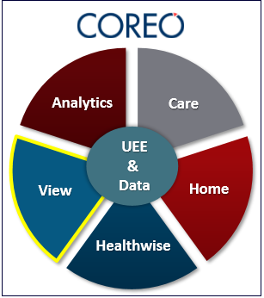

UEE allows its users to configure a Coreo application to view it in a single panel or configure multiple Coreo applications to view them in multiple panels on their device screens, with each application assigned to a panel.

Navvis & Company provides counsel to health systems, hospitals and physician groups on the development of innovative, market-linked strategies to build future-ready health systems, cultivate tomorrow’s leaders and strengthen strategic performance.

## Purpose of this document

This guide is the primary source of information about Navvis Unified Ecosystem Experience. It contains overviews, processes, and procedure to use the Unified Ecosystem Experience application effectively.

## Intended audience

1. The regular users of the Unified Ecosystem Experience application who include the following personnel:

* Clinical staff and hospital administrators
* Employees, consultants, contractors or agents of the clinicians or patients who have been invited by the clinician or patient to access and use the service to participate in the care of the patient.
* Any other person or entity involved in the care of the patient including patient's care providers, patient's insurer or payer, or a social worker, or government agencies.

1. Unified Ecosystem Experience administrator users who are assigned the task of managing the regular users of the Unified Ecosystem Experience application

## Organization of the document

This document contains the following modules:

* Module 1, “User onboarding”
* Module 2, “UEE panel view—Screen layout and navigation”
* Module 3, “Display settings for UEE panel view”
* Module 4, “Creating presets for single panel format”
* Module 5, “Creating presets for multi-panel format”
* Module 6, “Editing the toolbar”
* Module 7, “Panel formats and screen resolutions”
* Module 8, “Synchronizing patient records”

## Document Conventions

This document uses the following conventions:

| Convention | Item |
| --- | --- |
| **boldface** font | **Menu** items, **Tab** names, **Text** **box** names, **List** **box** names, **Button** names and **Navigation** paths |
| Text in blue | Hyperlinks |
|  | Note: Notes contain helpful suggestions. A note will inform the reader about any deviation in the sequence of instructions or helps the reader save time in understanding why something is not working. |
|  | Tip: The information will help the user solve a problem faster, or to perform an action in a different way. |
|  | Caution alerts the reader to avoid doing something that could result in loss of data or any other damage. |

## Recommended Browsers Versions for UEE

The Unified Ecosystem Experience application is available on standard screen devices and widescreens devices.

| Browser | Version |
| --- | --- |
| Google Chrome | 74 |
| MS Internet Explorer | 11 |
| MacBook - Safari | 12 |

Unified Ecosystem Experience (UEE)-User Function

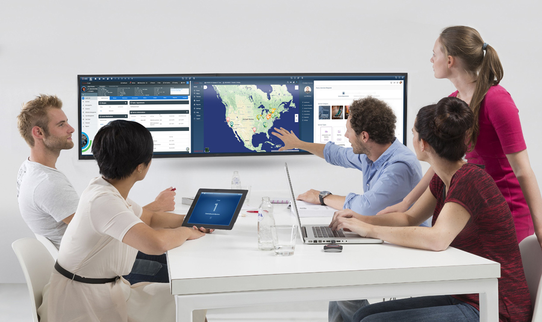

# Coreo UEE Overview

Coreo UEE provides the convenience of viewing all the Coreo applications that the users have access to on standard screens and widescreens either in a single panel mode or in a multi-panel mode.

The following illustration gives an overview of the UEE application:

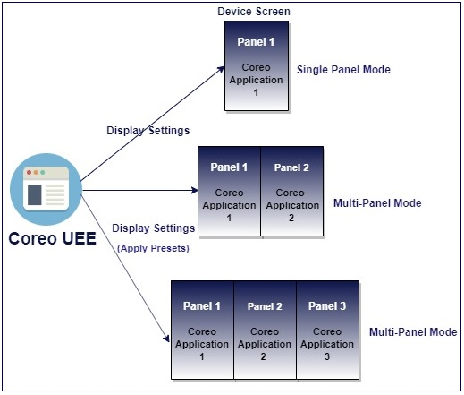

1. Coreo UEE Overview

Use the display settings feature in UEE to configure the following modes on your device screen:

* Single panel mode: You can configure a Coreo application to view it in a single panel layout. The single panel mode is available on standard screens (4:3 aspect ratio resolutions) and on widescreens (16:9 and 16:10 aspect ratio resolutions)
* Double panel mode (Multi-panel mode): You can configure the Coreo applications to view them in a double panel layout, with each application assigned to a panel. The double panel mode is compatible with widescreens only. You can save the configurations of a double panel mode as presets.
* Triple panel mode (Multi-panel mode): You can configure the Coreo applications to view them in a triple panel layout, with each application assigned to a panel. The triple panel mode is compatible with widescreens only. You can save the configurations of a triple panel mode as presets.

UEE also allows its users to pin the Coreo applications and presets on the toolbar of the UEE screen to access and apply the screen configurations easily.

# User Onboarding

A first-time user of Unified Ecosystem Experience (UEE) receives an automated email verification link from the Okta system administrator to activate the Okta account.

Okta Single Sign-On(SSO) provides a single secure home page to log into the UEE application and other applications that are part of the Coreo ecosystem.

As a user, you can access only those Coreo applications for which you have permission for and based on the role assigned to you by your system administrator.

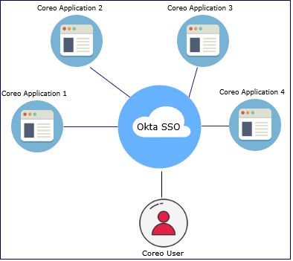

1. Okta Single Sign On (SSO) for Coreo applications

## Log into UEE—First Time User

Follow these steps to activate the Navvis-Okta SSO account to access the Unified Ecosystem Experience application:

1. Open the email link sent to your email inbox by the Okta administrator.

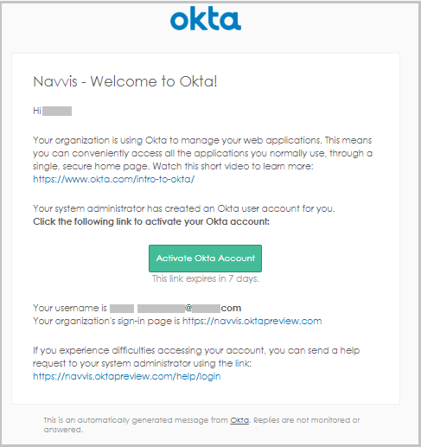

1. Email Notification
2. Select the ActivateAccLinkGreenBox.png link. The **Create your Navvis account** screen opens.

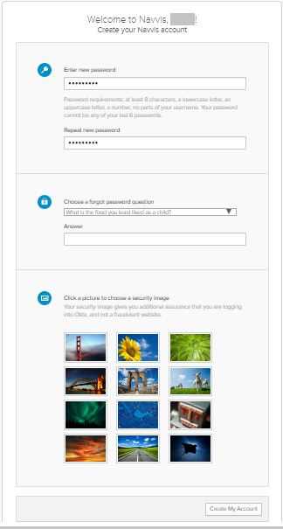

1. Create Your Navvis Account Screen
2. Enter the new password in **Enter new password**. The password must be at least 8 characters long and a maximum of 25 characters.

The password must be a combination of these following characters:

| Description | Characters |
| --- | --- |
| Upper case characters | A – Z |
| Lower case characters | a – z |
| Digits | 0 – 9 |
| Special characters | ~ ! @ # $ % ^ & * _ - + = ` | \ () {} [] : ; " ' < > , . ? / |

1. System Accepted Password Characters
2. Reenter the password in the **Repeat new password** box.
3. The user must add a security question to reset a new password in the scenario where user may forget the password during the future use.
4. Under **Choose a forgot password** question, select the arrow to view the questions.

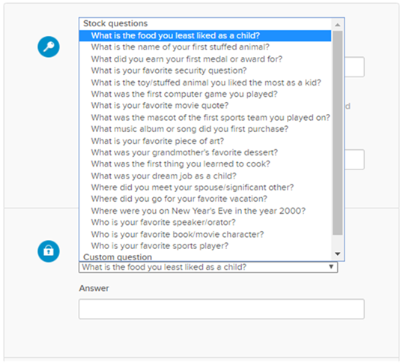

1. Choose A Forgot Password Question in the Create Your Navvis Account Screen
2. Choose a security question from the list.
3. In the **Answer** box, enter the answer. You must remember this answer because it is used at a later date to reset a forgotten or expired password.
4. Choose a picture as a security image in the **Create your Navvis account** screen and then select **Create My Account**.

|  |  |
| --- | --- |
|  | The security image displays in the NAVVIS Sign In screen on entering the user name. |

1. The **Navvis** landing screen opens.

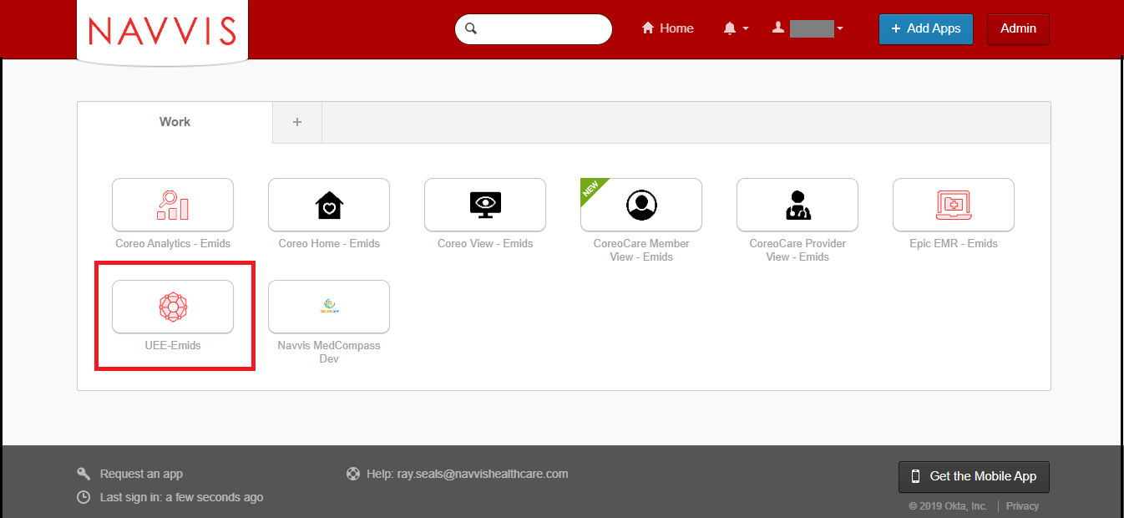

1. NAVVIS Landing Screen
2. Select the **UEE - Emids** button on the landing screen. The Coreo applications that you see on the Navvis landing screen depends upon the user role and permissions assigned to you by your NAVVIS system administrator.
3. The **NAVVIS Sign in** screen opens.

|  |  |
| --- | --- |
|  | Once the user accepts EULA and the Navvis-Okta SSO account is activated, the new user becomes an existing user.  As an existing user, go to [navvis.oktapreview.com](https://navvis.oktapreview.com/) to open the NAVVIS Sign in screen. |

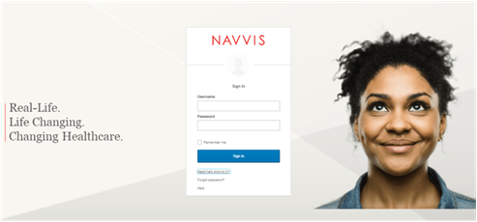

1. NAVVIS Sign In Screen
2. Enter the user ID in the **Username** box.
3. Enter the password in the **Password** box. The password must be at least 8 characters long and a maximum of 25 characters.
4. Select **Sign In**.
5. The EULA screen displays for a first-time user of UEE. A first-time user of UEE is required to accept the EULA (End User License and Business Associate Agreement) before accessing the UEE application.

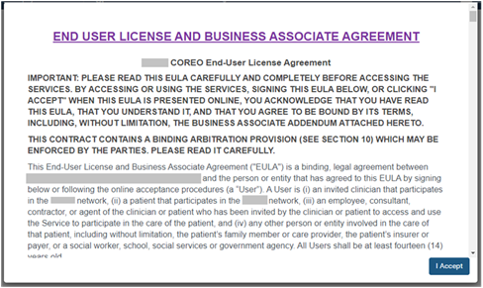

1. EULA PAGE
2. Read the terms and conditions and select the **I Accept** button. Your NAVVIS account is activated successfully and the UEE home page opens.

## About locked Navvis-Okta SSO account

The Navvis-Okta SSO account locks for the following reasons:

* The user exceeds five failed login attempts within 24 hours. The login attempts fail when the user enters an incorrect password.

The locked account resets after 24 hours and the user can log in to the account after 24 hours without contacting the Okta system administrator.

|  |  |
| --- | --- |
|  | To unlock the NAVVIS account immediately after the five failed login attempts, contact the Okta system administrator. |

* The Okta system administrator can lock the NAVVIS-Okta SSO account as per the company lock account policy.

## Reset a forgotten or expired password

The Okta Single Sign-On password policy specifies that the password expires after 60 days, and the user must reset the password periodically.

Also, if the user forgets the password, Navvis-Okta gives the option to reset the password.

Follow these steps to reset the password:

1. Go to [navvis.oktapreview.com](https://navvis.oktapreview.com/) to open the **Navvis Sign in** screen.

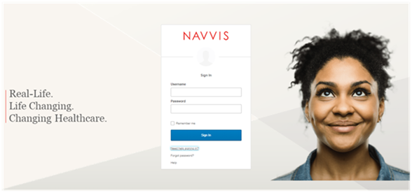

1. NAVVIS Sign In Screen - Forgot password? Option
2. Select the **Need help signing in?** drop-down list.
3. Select the **Forgot password?** option to open the **Reset Password** screen.

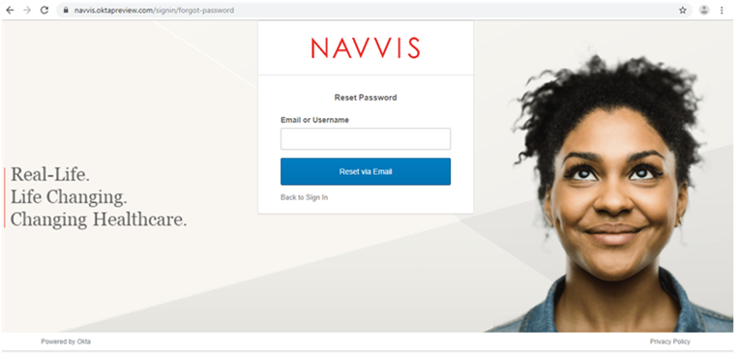

1. Reset Password Screen
2. Enter the e-mail or the user name in the **Email or Username** box.
3. Select **Reset via E-mail**. The user can reset the password using the verification link sent to the user’s email address.
4. Reset the password with the following considerations:

* The new password cannot be among the previous six passwords.
* The password expires after 60 days and the user must reset the password periodically.
* The user will be locked out of the application after five failed login attempts. The login attempts fail when the user enters an incorrect password. Contact the Okta administrator to reset the password.

On the successful resetting of the password, the new password is reset for the Navvis-Okta Single Sign-On account.

# UEE panel view— Screen Layout and Navigation

The screen layouts in the UEE application are similar in appearance. However, a few user interface elements differ depending upon the following reasons:

* The number (one, two or three) of panels that are displayed on the screen
* The type of user login — a first time user of UEE or an existing user
* The user’s role and permissions

The following figure is the default screen view of the UEE application when the user logs into the application as a first time user.

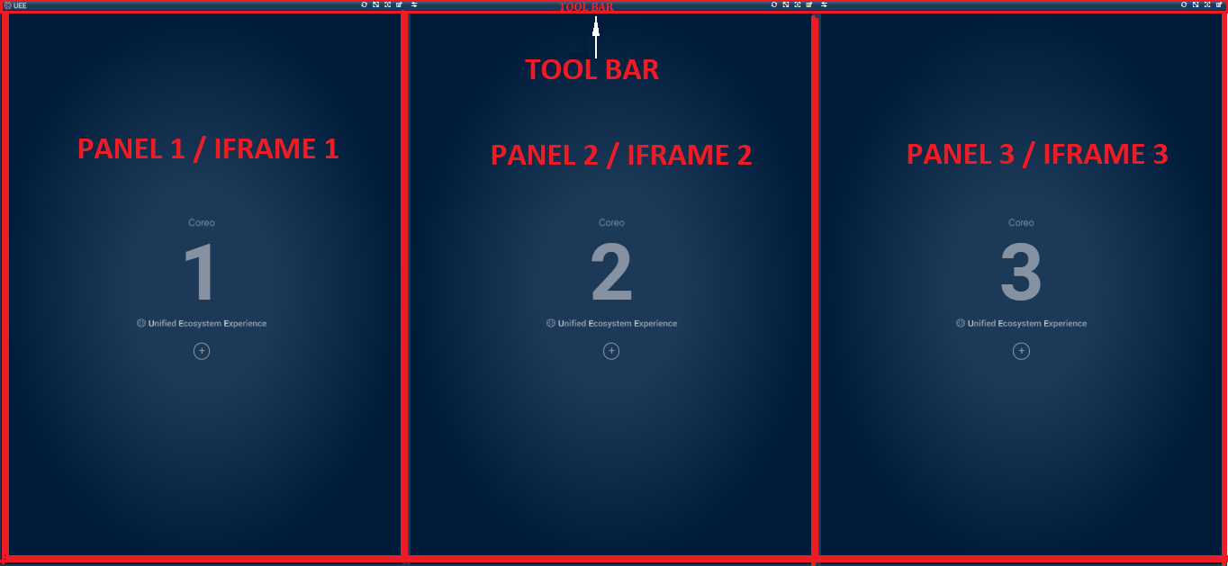

1. UEE Screen‒Triple Panel View

The UEE home page layout includes the following areas:

* Toolbar: Includes buttons to apply the presets to the panels, to access the display settings for the panel, and to control the magnification settings of the panel screen.
* Panel or Iframe: Each Coreo application can be assigned to a panel and can have a maximum of three panel on the device screen.

Toolbar elements

The toolbar runs across all the three panels on the UEE screen. The **Refresh** button, the **Maximize Display** button, the **Help** button, and the **Display** **Settings** button are available for each panel and are located in the upper-right corner of the panel on the toolbar.

The **Swap** button is located in the upper-left corner of the second panel and third panel on the tool bar.

Refer to the following table to view details about the elements on the tool bar.

| Icon | Element name | Description |
| --- | --- | --- |
|  | **UEE** Logo | The UEE logo |
|  | **Refresh** button | Use this to refresh the Coreo application of that panel. |
|  | **Maximize Display** toggle button | Use this button to enlarge the panel layout view to fit the entire screen of the device. Select the same button or select **Esc** on the keyboardto exit the full screen. |
|  | **UEE Help** button | Use this button to open the UEE user help document. |
|  | **Display Settings** button | Use this button to open the **Display Settings** pop-up window. In the pop-up window, you can create, modify, or delete presets. You can also pin a Coreo application or a preset to the tool bar using this window. |

1. Toolbar Elements

## Panel elements

Refer to the following table to view details about the elements in the panel.

| Icon | Element name | Description |
| --- | --- | --- |
|  | Panel 1 | The first panel. The UEE screen can display a maximum of three panels on the device screen. The first panel is the Left (**L**) panel. |
|  | Panel 2 | The second panel.  The second panel is the Central (**C**) panel. |
|  | Panel 3 | The third panel.  The third panel is the Right (**R**) panel. |
|  | **Display Settings** button | Use this button to open the **Display Settings** pop-up window. You can click anywhere in the panel area to open the **Display** **Settings** window . |
|  | UEE logo | The UEE logo |

# Display settings for UEE panel view

## Display Settings window—layout and navigation

UEE provides the flexibility to configure different Coreo applications to view in different panels on the device screen.

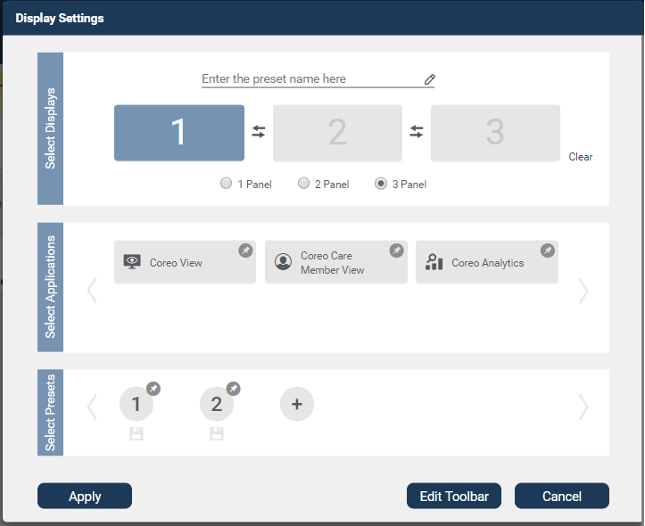

1. Display Settings pop-up window

Refer to the following table to view details about the elements in the Display Settings window.

| Icon | Element name | Description |
| --- | --- | --- |
|  | **Select Displays** group | In this group, do the following:   * Select the number of panels to display on the device screen. * Swap the applications between the panel slots when configuring the applications for a double panel view and a triple panel view. * Delete the applications assigned to the panel slots using the **Clear** button. |
|  | Panel 1 slot | Use this slot to assign a Coreo application to the first panel on your display screen.  In a single panel view, you can display the Coreo application either in the left panel, or in the central panel or in the right panel. |
|  | Panel 1 slot | An empty panel slot |
|  | Panel 1 slot | An application assigned to the panel slot |
|  | **L C R** position buttons | Use these buttons to position the application view either in the (**L**) left panel, or in the (**C**) central panel or in the (**R**) right panel on the device screen.  These buttons are available only when you select the **1 Panel** button. |
|  | Panel 2 slot | Use this slot to assign a Coreo application to the second panel on your display screen.  In a 2 panel mode, you can assign an application each to both panel 1 and panel 2. |
|  | Panel slot - Highlighted | A selected panel slot to which an application can be assigned. |
|  | Panel slot – Non-Highlighted | A cleared panel slot. |
|  | Panel 3 slot | Use this slot to assign a Coreo application to the third panel on your display screen.  In a 3 panel mode, you can assign an application each to panel 1, panel 2 and panel 3. |
|  | Swap button | Use this button to swap the Coreo applications between the panel slots when configuring the applications for a double panel view and a triple panel view. |
|  | **Clear** button | Use this button to delete the applications assigned to the panel slots. |
|  | Panel radio button group | In this button group, select the number of panels to display on the device screen. |
|  | **1 Panel** button | Select this button to display the Coreo application in a single panel on the device screen. |
|  | **2 Panel** button | Select this button to display the Coreo applications in a double panel on the device screen, with each application configured to a panel. |
|  | **3 Panel** button | Select this button to display the Coreo applications in a triple panel on the device screen, with each application configured to a panel. |
|  | **3 Panel** button - Selected | A selected radio button |
|  | Preset name box | Enter the name of the preset in this box to save the preset and apply it to the device screen.  You can save only double panel and triple panel configurations as presets. |
|  | **Select Applications** group | In this group, do the following:   * Select the application to assign to the panel slot. * Pin the applications to the toolbar of the UEE screen using the **Edit Toolbar** button in the lower-right corner of the **Display Settings** window. |
|  | Application slots | The applications to assign to the **1 Panel** slot to configure a single panel mode.  **Coreo View** – **Prioritized View**, **Coreo** **View – Bed View**, and **Coreo View – Geomap View** applications are available for 1 panel slot only. |
|  | Application slot - blue | A selected application.  An application that is assigned to a panel slot. |
|  | Pin icon - blue | A pinned application.  An application that is pinned to the toolbar of the UEE panel screen. |
|  | Application slot - grey | An application that is not assigned to a panel slot for a given configuration. |
|  | Pin icon - grey | A non-pinned application. |
|  | Application slots | The applications to assign to the **2 Panel** slots and **3 Panel** slots to configure double panel mode and triple panel mode, respectively. |
|  | Left Chevron icon | Use this to navigate to the left and access the applications that are not within the default view of the **Display Settings** window. |
|  | Right Chevron icon | Use this to navigate to the right and access the applications that are not within the default view of the **Display Settings** window. |
|  | **Select Presets** group | In this group,   * save the configurations as presets to apply to the UEE panel screen for a double panel mode and a triple panel mode. * Pin the applications to the toolbar of the UEE screen using the **Edit Toolbar** button in the lower-right corner of the **Display Settings** window. |
|  | Preset icon |  |
|  |  |  |
|  |  |  |
|  |  |  |
|  |  |  |

# Configuring a Single Panel View

## Create a Single Panel View

## Apply a Single Panel View

# Creating Presets for Multi-Panel View

## Create presets for double panel view

## Apply a double panel preset

## Pin a double panel preset to the toolbar

## Save and apply a double panel preset

## Create presets for triple panel view

## Apply a triple panel preset

## Pin a triple panel preset to the toolbar

## Save and apply a triple panel preset

## Switching between single panel view and multi-panel view

## Switching between double panel view and triple panel view

# Editing the Presets and Toolbar Preferences

## UI Elements on the Edited Toolbar

## Pin a Preset to the Toolbar

## Apply a Coreo Application to the Screen

# Panel formats and screen resolutions

## Panel formats in standard view and widescreen view

## Screen resolutions for optimal display of pinned applications

# Viewing synchronized patient records

Synchronize patient records across applications in panel view

Appendices

Credits

[www.bloomberg.com/profile/company/3553499Z:US](http://www.bloomberg.com/profile/company/3553499Z:US)

[www.navvishealthcare.com/](http://www.navvishealthcare.com/)

[www.linkedin.com/company/navvishealthcare](http://www.linkedin.com/company/navvishealthcare)

[www.pitchbook.com/profiles/company/88126-75](http://www.pitchbook.com/profiles/company/88126-75)

[www.crunchbase.com/organization/navvis-company](http://www.crunchbase.com/organization/navvis-company)

[www.healthcareitnews.com/blog/defining-population-health](http://www.healthcareitnews.com/blog/defining-population-health)

Glossary

[Glossary term – Description]

[Glossary term – Description]

[Glossary term – Description]

[Glossary term – Description]

[Glossary term – Description]

……………………..

Index

[Depending on the size or complexity of the final document, insert an index to assist the user in locating specific information. Index entries correspond to tags or categories, and are useful in navigating long books.]

[Index term – *page number*]

[Index term – *page number*]

[Index term – *page number*]

[Index term – *page number*]

[Index term – *page number*]